Exercise 1

1. Create a `String?` variable called `profession`, but don't give it a value.
2. Then you'll have `profession` `null`. Get it? Professional?
3. Print the output.
4. Comment on the output you have seen.

Because the variable “profession” has no value at the moment.

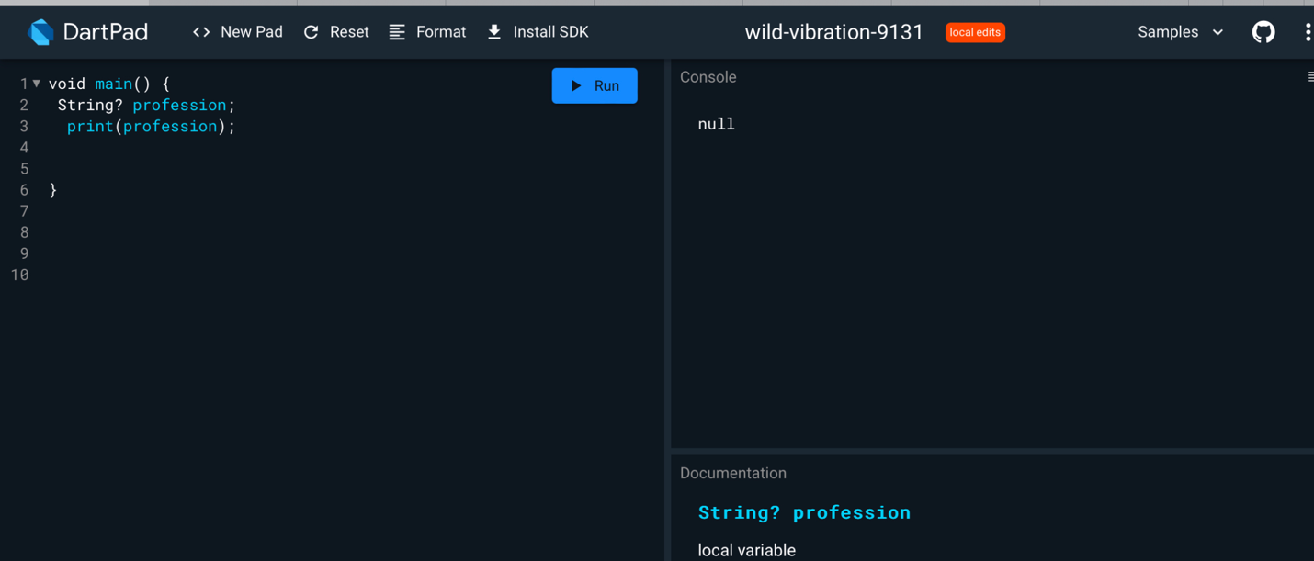

Exercise 2

1. Give `profession` a value of "basketball player".
2. Print the output.
3. Comment on the output you have seen.

I got the output “basketball player,” meaning that the profession variable now holds the value of a “basketball player.”

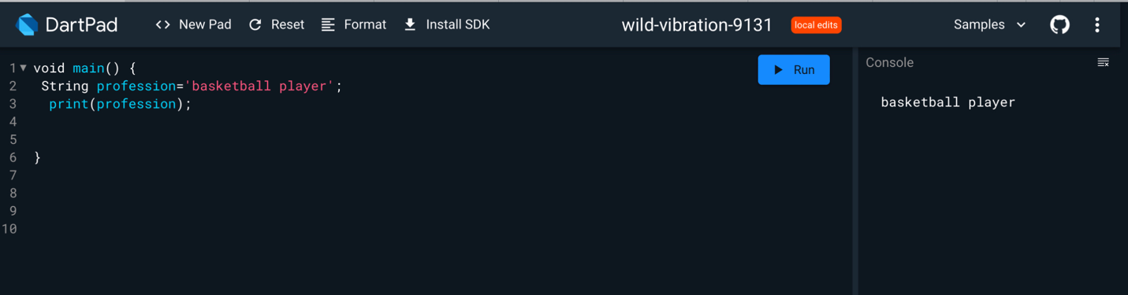

Exercise 3

1. Write the following line and then hover your cursor over the variable name. What type does Dart infer `iLove` to be? `String` or `String?`?

const iLove = 'Dart';

Set it as a String type.

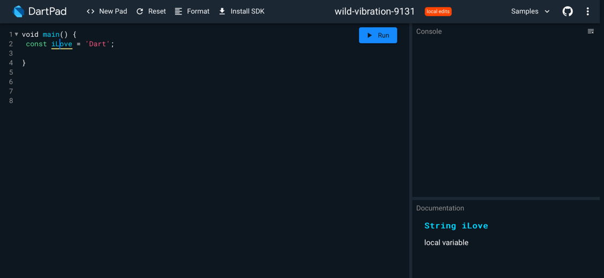

Challenge 1: Naming Customs

People around the world have different customs for giving names to

children. It would be difficult to create a data class to accurately

represent them all, but try it like this:

1. Create a class called `Name` with `givenName` and `surname` properties.
2. Some people write the surname last and some write it first.
3. Add a Boolean property called `surnameIsFirst` to keep track of this.
4. Not everyone in the world has a surname.
5. Add a `toString` method that prints the full name.

